# 01 - VPC

## ****1.1 Introduction****

* VPC stands for Virtual Private Cloud which is defined the users on the custom network resources
* AWS VPC will look familiar to anyone used to running a [physical Data Center (DC)](https://www.bmc.com/blogs/data-center-migration/). A VPC behaves like a traditional TCP/IP network that can be expanded and scaled as needed. However, the DC components you are used to dealing with—[such as routers, switches, VLANS, etc.](https://www.bmc.com/blogs/what-is-it-infrastructure-and-what-are-its-components/)—do not explicitly exist in a VPC. They have been abstracted and re-engineered into cloud software.

## ****1.2 Where VPC live?****

* All VPCs are created and exist in one—and only one—AWS region.
* The advantage of regionalization is that a regional VPC provides network services originating from that geographical area. If you need to provide closer access for customers in another region, you can set up another VPC in that region.
* Limiting VPC configurations to specific regions allows you to selectively provide network services where they are needed, as they are needed.

## ****1.3 What is CIDR block in VPC?****

* VPC IP address ranges are defined using Classless interdomain routing (CIDR) IPv4 and IPv6 blocks.

## ****1.3.1 How IPV4 works?****

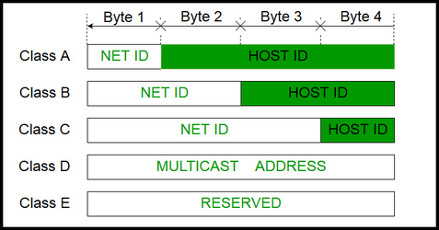

Generally, there are two notations in which IP address is written, dotted decimal notation and hexadecimal notation.

**Dotted Decimal Notation**:

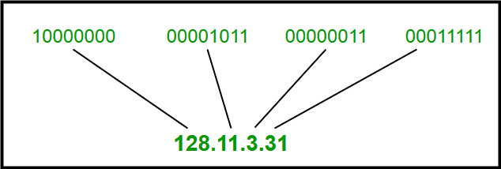

**Conversation of binary to decimal**

# ****1.3.1.1 How to convert binary to decimal ?****

The decimal number is equal to the sum of binary digits (dn) times their power of 2 (2n):

decimal = d0×20 + d1×21 + d2×22 + ...

#### ****Example #1****

Find the decimal value of 1110012:

|  |  |  |  |  |  |  |
| --- | --- | --- | --- | --- | --- | --- |
| **binary number:** | **1** | **1** | **1** | **0** | **0** | **1** |
| **power of 2:** | 25 | 24 | 23 | 22 | 21 | 20 |

1110012 = 1⋅25+1⋅24+1⋅23+0⋅22+0⋅21+1⋅20 = 5710

#### ****Example #2****

Find the decimal value of 1000112:

|  |  |  |  |  |  |  |
| --- | --- | --- | --- | --- | --- | --- |
| **binary number:** | 1 | 0 | 0 | 0 | 1 | 1 |
| **power of 2:** | 25 | 24 | 23 | 22 | 21 | 20 |

1000112 = 1⋅25+0⋅24+0⋅23+0⋅22+1⋅21+1⋅20 = 3510

**Hexadecimal Notation**:

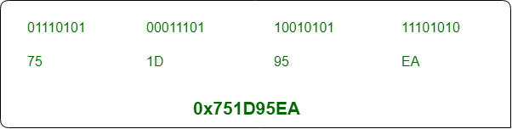

## ****1.3.1.2 Class A Public Address****

IP address belonging to class A are assigned to the networks that contain a large number of hosts.

* The network ID is 8 bits long.
* The host ID is 24 bits long.

The higher order bit of the first octet in class A is always set to 0. The remaining 7 bits in first octet are used to determine network ID. The 24 bits of host ID are used to determine the host in any network.

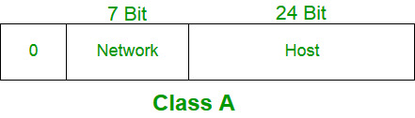

The default subnet mask for class A is 255.x.x.x. Therefore, class A has a total of:

* 2^7-2= 126 network ID (**here 2 addresses asubtracted because 0.0.0.0 and 127.x.y.z are special address.**)
* 2^24 – 2 = 16,777,214 host ID

**IP addresses belonging to class A ranges from 1.x.x.x – 126.x.x.x**

Class A addresses are for networks with large number of total hosts. Class A allows for 126 networks by using the first octet for the network ID. The first bit in this octet, is always set and fixed to zero. And next seven bits in the octet is all set to one, which then complete network ID. The 24 bits in the remaining octets represent the hosts ID, allowing 126 networks and approximately 17 million hosts per network. Class A network number values begin at 1 and end at 127.

* IP Range: **1.0.0.0 to 126.0.0.0**
  + First octet value range from 1 to 127
* Subnet Mask: 255.0.0.0 (8 bits)
* Number of Networks: **126**
* Number of Hosts per Network: **16,777,214**

## ****1.3.1.3 Class B Public Address****

IP address belonging to class B are assigned to the networks that ranges from medium-sized to large-sized networks.

* The network ID is 16 bits long.
* The host ID is 16 bits long.

The higher order bits of the first octet of IP addresses of class B are always set to 10. The remaining 14 bits are used to determine network ID. The 16 bits of host ID is used to determine the host in any network. The default sub-net mask for class B is 255.255.x.x. Class B has a total of:

* 2^14 = 16384 network address
* 2^16 – 2 = 65534 host address
  + IP addresses belonging to class B ranges from 128.0.x.x – 191.255.x.x.

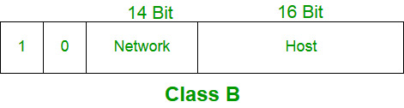

Class B addresses are for medium to large sized networks. Class B allows for 16,384 networks by using the first two octets for the network ID. The two bits in the first octet are always set and fixed to 1 0. The remaining 6 bits, together with the next octet, complete network ID. The 16 bits in the third and fourth octet represent host ID, allowing for approximately 65,000 hosts per network. Class B network number values begin at 128 and end at 191.

* **Range: 128.0.0.0 to 191.255.0.0**
  + First octet value range from 128 to 191
* Subnet Mask: 255.255.0.0 (16 bits)
* Number of Networks: 16,382
* Number of Hosts per Network: 65,534

## ****1.3.1.4 Class C Public Address****

* IP address belonging to class C are assigned to small-sized networks.
  + The network ID is 24 bits long.
  + The host ID is 8 bits long.

The higher order bits of the first octet of IP addresses of class C are always set to 110. The remaining 21 bits are used to determine network ID. The 8 bits of host ID is used to determine the host in any network. The default sub-net mask for class C is 255.255.255.x. Class C has a total of:

* + 2^21 = 2097152 network address
  + 2^8 – 2 = 254 host address

IP addresses belonging to class C ranges from 192.0.0.x – 223.255.255.x.

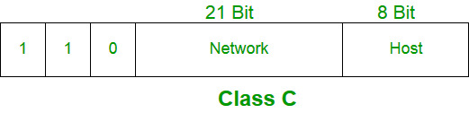

Class C addresses are used in small local area networks (LANs). Class C allows for approximately 2 million networks by using the first three octets for the network ID. In class C address three bits are always set and fixed to 1 1 0. And in the first three octets 21 bits complete the total network ID. The 8 bits of the last octet represent the host ID allowing for 254 hosts per one network. Class C network number values begin at 192 and end at 223.

* Range: **192.0.0.0 to 223.255.255.0**
  + First octet value range from 192 to 223
* Subnet Mask: 255.255.255.0 (24 bits)
* Number of Networks: 2,097,150
* Number of Hosts per Network: 254

## ****For Example****

The first 24 bits are identified as the **network address**, with the last 8 bits (the remaining zeros in the subnet mask) identified as the **host address**. This gives you the following:

**11000000.10101000.01111011**.00000000 -- Network address (192.168.123.0)

00000000.00000000.00000000.**10000100**-- Host address (000.000.000.132)

## ****1.3.1.5 Class D Public Address****

* IP address belonging to class D are reserved for multi-casting. The higher order bits of the first octet of IP addresses belonging to class D are always set to 1110. The remaining bits are for the address that interested hosts recognize.

Class D does not posses any sub-net mask. IP addresses belonging to class D ranges from 224.0.0.0 – 239.255.255.255.

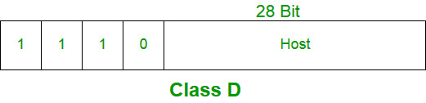

Classes D are not allocated to hosts and are used for multicasting.

* Range: 224.0.0.0 to 239.255.255.255
  + First octet value range from 224 to 239
* Number of Networks: N/A
* Number of Hosts per Network: Multicasting

## ****1.3.1.6 Class E Public Address****

* IP addresses belonging to class E are reserved for experimental and research purposes. IP addresses of class E ranges from 240.0.0.0 – 255.255.255.254. This class doesn’t have any sub-net mask. The higher order bits of first octet of class E are always set to 1111.

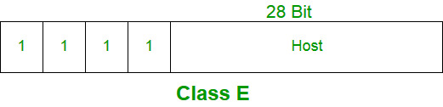

Classes E are not allocated to hosts and are not available for general use. They are reserved for research purposes.

* Range: 240.0.0.0 to 255.255.255.255
  + First octet value range from 240 to 255
* Number of Networks: N/A
* Number of Hosts per Network: Research/Reserved/Experimental

## ****1.3.2 What is subnet mask?****

Every device has an IP address with two pieces: the client or host address and the server or network address. IP addresses are either configured by a DHCP server or manually configured (static IP addresses). The subnet mask splits the IP address into the host and network addresses, thereby defining which part of the IP address belongs to the device and which part belongs to the network.

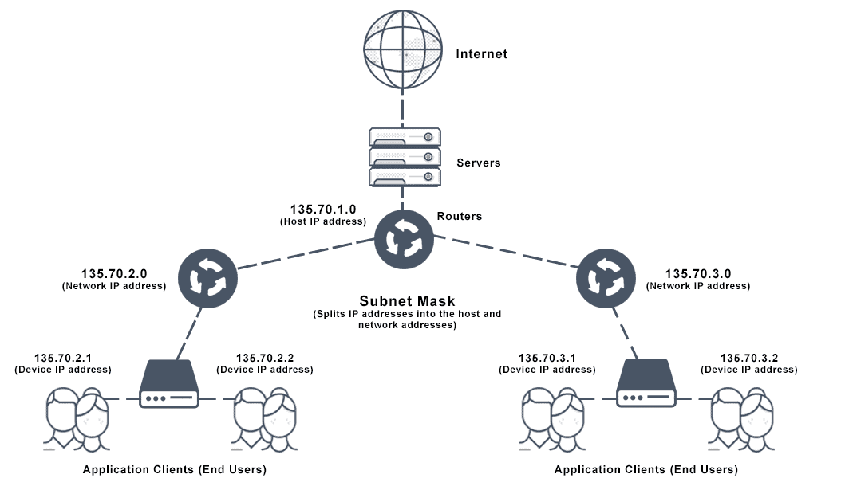

## ****1.3.2.1 How Do IP Address and Subnet Mask Work Together?****

In TCP/IP configuration, we cannot determine whether a part of the IP address is used as network or host address unless we get more information from a subnet mask table. If the subnet mask example is **255.255.255.0**, and since 255 in binary notation equals 11111111, so the subnet mask is:

11111111.11111111.11111111.0000000.

Lining up the IP address and the subnet mask together, the network and host portions of the address can be separated:

11000000.10101000.01111011.10000100 -- IP address (192.168.123.132)

11111111.11111111.11111111.00000000 -- Subnet mask (255.255.255.0)

**11000000.10101000.01111011**.********* (**Value I**)

A bitwise AND operation will basically save the networking portion of the address and discard the host portion.

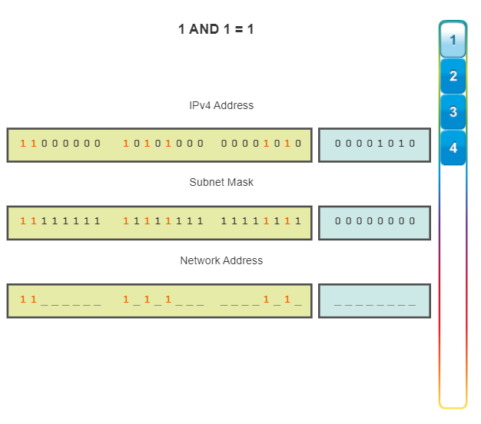

The first 24 bits are identified as the **network address**, with the last 8 bits (the remaining zeros in the subnet mask) identified as the **host address**. This gives you the following:

**11000000.10101000.01111011**.00000000 -- Network address (192.168.123.0)

00000000.00000000.00000000.**10000100**-- Host address (000.000.000.132)

So now you know, for this example using a 255.255.255.0 subnet mask, that the network address is 192.168.123.0, and the host address is 0.0.0.132. When a packet arrives on the 192.168.123.0 subnet, and it has a destination address of 192.168.123.132 inside **192.168.123.0 subnet**

## ****1.3.3 what is IPV4 Classless inter-domain routing (CIDR)?****

A system called **Classless Inter-Domain Routing**, or CIDR, was developed as an alternative to traditional subnetting. The idea is that you can add a specification in the IP address itself as to the number of significant bits that make up the routing or networking portion.

For example, we could express the idea that the IP address 192.168.0.15 is associated with the netmask 255.255.255.0 by using the CIDR notation of 192.168.0.15/24. This means that the first 24 bits of the IP address given are considered significant for the network routing.

